## Higher National Diploma in Information Technology

**Object Oriented Programming**

**Lab Sheet 03**

1 . Write a program NamePrinter that displays your name inside a box on the console screen, like this:

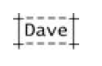

2. Write a program FacePrinter that prints a face, using text characters, hopefully better looking than this one:

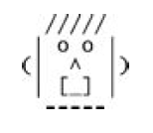

**3. Change the following program to use compound (Arithmetic) assignments:**

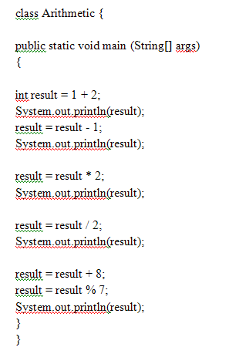

**4. What will be the output of the program?**

**In the following program, explain why the value "6" is printed twice in a row?**

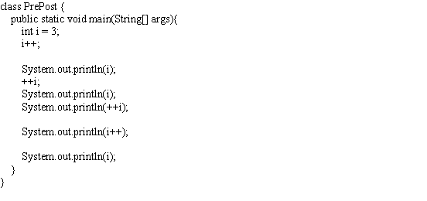

**5. The following program demonstrates the bitwise operators. What will be the output of the program?**

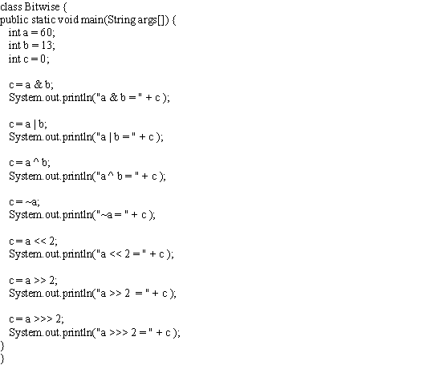

**6. Write a program to check whether the given number is even or odd?**

**For this, you have taken an integer variable num and initialized to 150.**

**7. Write a program using if statement to determine the largest number of two given numbers.**

**a=31**

**b=72**